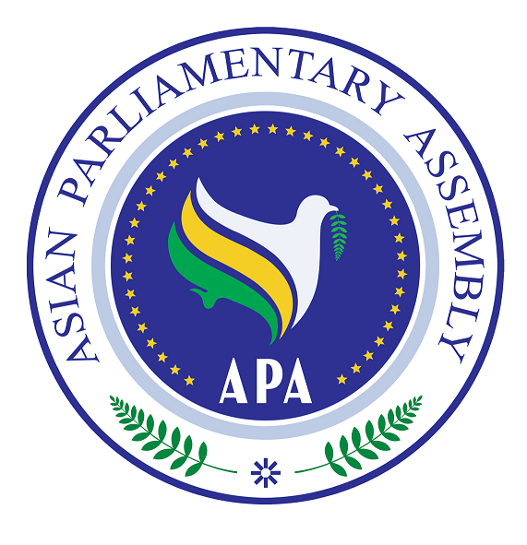

SG/Rep/2009/03
31 May 2009

Follow up Report of the APA Secretary-General on
Combating Corruption

Background:

- The APA Plenary decided in its resolution on Combating Corruption contained in APA/Res/2008/18, dated 29 November 2008, to

- Invite Member Parliaments that have not yet ratified the United Nations Convention against Corruption to do so as early as possible and undertake measures to implement it;
- Invite Member Parliaments to report to the Secretariat, for purpose of exchange of information, about their national experiences with “Legislative Code of Conduct”, “Freedom of Access to Information Laws”, “Conflict of Interests Laws” and “Whistle Blowers and Witness Protection Laws”, and, where available, provide the text of the law;
- Encourage Member Parliaments to report to the Secretariat, for purpose of exchange of information and best practices, about their oversight system, parliamentary committees entrusted with the task of oversight, number of its staff and resources available to them to effectively carry out their mandate;
- Decide to designate one of our APA delegates as the focal point for coordination of activities, networking and dissemination of information within APA;
- Urge Member Parliaments to complete and return to the Secretariat the self-assessment form attached to the APA Plan of Action;
- Request the Secretary-General to continue to collect information and legislative and regulatory texts from Member Parliaments and relevant inter-parliamentary and non-governmental organizations in order to promote an informed exchange of information and knowledge about effective anti-corruption policies and measures;
- Urge Member Parliaments, relevant inter-parliamentary and non-governmental organizations, as well as financial institutions to extend to the Secretary-General their full support and assistance in collection and analysis of corruption-relevant laws and regulatory texts and in implementation of the present resolution.
- Also Request the Secretary-General to report on implementation of the present resolution to the next meeting of the Sub-Committee on Combating Corruption.

- Pursuant to Operative Paragraph 9 of the Resolution above, the Secretary-General presents this report which is a follow up to its Report contained in SG/Rep/ 2008/08.

Implementation of the Resolution

- The Secretary-General wrote to all APA Member and Observer parliaments on 21 April 2009 and sought their views on implementation of Resolution APA/Res/2008/18. The Secretary-General recalled that Operative Paragraphs 3, 4, 5, 6 and 8 of the Resolution each invites Member Parliaments to present a report to the Secretariat to assist the Secretary-General in collection and analysis of corruption-relevant laws and regulatory texts and in the implementation of the Resolution. The Secretary-General made urgent request for information requested in Paragraphs 3 and 5: Member Parliaments experience with “Code of Conduct of Legislatures”. “Freedom of Access to Information Laws”, “Conflict of Interests Laws” and “Whistle Blowers and Witness Protection Laws”, as well as the name of their delegate assigned as the “Focal Point” for networking and dissemination of information within APA on fighting corruption.

- The Secretary-General hopes that Member Parliaments would soon designate one of their APA delegates as the focal point for development and coordination of anti-corruption programs and activities of the APA as well as for dissemination of information within the APA.

- The House of Representatives of the Republic of the Philippines forwarded to the APA Secretariat the Title of some Republic Acts and House Bills relevant to Combating Corruption, including Code of Conduct of legislatures, Conflict of Interests, Freedom of Access to Information, Whistle Blowers and Witness Protection. These Republic Acts and House bills of the Republic of the Philippines are reproduced as Annex I to this Report for information of the APA Member Parliaments.

- In accordance with Operative Paragraph 7, the Secretary-General collected some legislative and regulatory texts in order to promote an informed exchange of information and knowledge about effective anti-corruption policies and measures as follows;

- UNDCP Model Witness Protection Bill, Annex II
- Article 8 of the United Nations Convention against Corruption about “Codes of Conduct for Public Officials”, Annex III
- Code of Conduct for Public Officials contained in the annex to General Assembly Resolution 51/59 of 12 December 1996, Annex IV
- ADB OECD Anti-Corruption Initiative for Asia-Pacific, Annex V

- The Secretary-General looks forward to informative discussion within the meeting of the Sub-Committee on Corruption to be held on 18 June 2009 in Jakarta, Indonesia. It is also hoped that Member Parliaments would address the following issues, in their statements (General Debate):

- Elaborate on the status of the United Nations Convention against Corruption in their countries and whether enabling national legislations have been adopted. If so, provide a copy to the Secretariat and elaborate on its features.
- Provide information orally and in writing about their national experiences with anti-corruption legislative framework including “code of conduct for legislators and other public officials”, “freedom of access to information laws”, “conflict of interests laws”, “witness protection laws”, “financing political election laws” and other legislative experience dealing with corruption.
- Provide the name and particulars of the APA delegate designated as the APA focal point for anti-corruption efforts of the APA.
- Complete and return to the secretariat the self-assessment form attached to the APA Plan of Action.
- Address the question of institutional framework that needs to be developed to pursue implementation of the APA Plan of Action. In this context, the Sub-Committee participants may refer to the APA Plan of Action contained in APA/Res/2007/05/Annex of 19November 2007 and the Secretary-General Report on Corruption contained in SG/Rep/2008/08 of 20 September 2008. They are expected to discuss and provide guidance for the Secretariat on the institutional mechanism needed to move forward. They may also request the Secretary-General to submit a report on this issue to the next meeting of the Sub-Committee in 2010.

